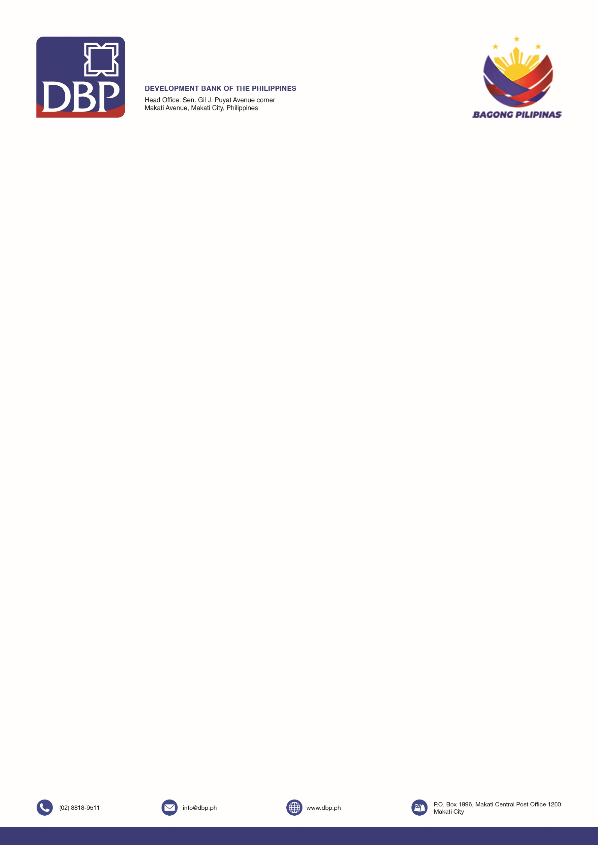

**DEVELOPMENT BANK OF THE PHILIPPINES**

**BBG – NORTHERN MINDANAO**

3F DBP Cagayan de Oro Bldg., T. Neri St. corner

Corrales Ave., Cagayan de Oro City, Philippines

**INVITATION TO BID**

**FOR**

**ONE (1) LOT SUPPLY, DELIVERY, AND INSTALLATION OF SIGNAGES FOR VARIOUS BBG-NORTHERN MINDANAO BRANCHES**

**BID REFERENCE NO. 2025-002**

1. The **Development Bank of the Philippines**, through the**Corporate Budget for 2025**intends to apply the sum of **Two Million Four Hundred Fifty-Three Thousand One Hundred Ninety-One Pesos and Eight Centavos only (₱2,453,191.08)**, inclusive of all applicable taxes, being the Approved Budget for the Contract (ABC) to payments under the contract for the **One (1) Lot Supply, Delivery, and Installation of Signages for Various BBG-Northern Mindanao Branches,** with details as follows:

|  |  |  |  |
| --- | --- | --- | --- |
| **BRANCH** | **UNIT** | **PARTICULARS** | **Approved Budget for the Contract (inclusive of taxes)** |
| Cagayan de Oro | 1 | Horizontal Branch Signage | ₱299,000.00 |
| Claver | 1 | Horizontal Branch Signage | ₱100,000.00 |
| Malaybalay | 3 | Flag Type ATM Signage - Offsite | ₱362,232.63 |
| 1 | Flag Type ATM Signage – Offsite (Wall Mounted) | ₱67,869.11 |
| San Jose Dinagat | 1 | Flag Type ATM Signage - Onsite | ₱120,744.21 |
| 1 | Horizontal Branch Signage | ₱61,588.80 |
| Siargao | 3 | Flag Type ATM Signage - Offsite | ₱300,000.00 |
|  | 1 | **Flag Type ATM Signage - Offsite | ₱60,000.00 |
| Surigao | 1 | Horizontal Branch Signage | ₱104,000.00 |
| Trento | 1 | Horizontal Branch Signage | ₱221,000.00 |
| Villanueva | 5 | *Flag Type ATM Signage – Offsite (Directional Signage) | ₱496,001.55 |
| 1 | Horizontal Branch Signage | ₱144,924.78 |
| 1 | Pylon Branch Signage | ₱115,830.00 |
| **TOTAL** | | | ₱2,453,191.08 |

***\**** *Directional Signage is not lighted*

*\*\* Existing signage steel post that are not included for replacement shall be repainted*

1. The **Development Bank of the Philippines** now invites bids for the above-cited procurement project. Bids received in excess of the ABC shall be automatically rejected at bid opening.Delivery of the Goods and Completion of Works is required **within Sixty (60) calendar days from receipt of Notice to Proceed (NTP)**. Bidders should have completed contracts similar to the Project at least **five (5) years** from the date of submission and receipt of bids. The description of an eligible bidder is contained in the Bidding Documents, particularly, in Section II. Instructions to Bidders.
2. Bidding will be conducted through competitive bidding procedures using a non-discretionary “pass/fail” criterion as specified in the IRR of RA No. 12009.

Bidding is restricted to Filipino citizens/sole proprietorships, partnerships, or organizations with at least sixty percent (60%) interest or outstanding capital stock belonging to citizens of the Philippines, and to citizens or organizations of a country the laws or regulations of which grant similar rights or privileges to Filipino citizens, pursuant to RA No. 5183.

1. Interested Bidders may obtain further information from the **Development Bank of the Philippines** and inspect the Bidding Documents at the address given below on **Mondays to Fridays from 9:00 AM to 3:00 PM.**
2. A complete set of Bidding Documents may be acquired by interested Bidders on **October 1, 2025**from the address given belowupon payment of the applicable non-refundable fee for the Bidding Documents, pursuant to the latest Guidelines issued by the GPPB, in the amount of **Five Thousand Pesos** **(P5,000.00)**. The Procuring Entity shall allow the bidder to present its proof of payment for the fees via physical presentation of original DBP Official Receipt or sending of scanned copy of the DBP Official Receipt via email (*nmbg@dbp.ph*).

It may also be downloaded free of charge from the website of the Philippine Government Electronic Procurement System (PhilGEPS) ([*www.philgeps.gov.ph*](http://www.philgeps.gov.ph)) and DBP Website ([*www.dbp.ph*](https://www.dbp.ph/procurement/))*,* provided that Bidders shall pay the applicable fee for the Bidding Documents not later than the submission of their bids.

1. The **Development Bank of the Philippines**will hold a Pre-Bid Conference on **October 10, 2025 at 9:00AM** at **BBG-NM Conference Room, 3/F DBP Cagayan de Oro Building, Tirso Neri St. corner Corrales Avenue, Cagayan de Oro City**and/or throughvideo conferencing via **Zoom or Microsoft Teams***,* which shall beopen to prospective Bidders.

1. Bids must be duly received by the Bids and Awards Committee (BAC) Secretariat through manual submission at the office address indicated below*,* on or before **October 22, 2025 on or before 9:00AM***.* Late bids shall not be accepted.
2. All Bids must be accompanied by a Bid Security in any of the acceptable forms and in the amount stated in **ITB Clause 16.1.**
3. Bid opening shall be on **October 22, 2025 at 10:00AM** at **DBP Training Center, 2/F DBP Cagayan de Oro Building, Tirso Neri St. corner Corrales Avenue, Cagayan de Oro City**and/or throughvideo conferencing via **Zoom or Microsoft Teams**. Bids will be opened in the presence of the Bidders’ representatives who choose to attend the activity.
4. The Pre-Bid Conference shall be open to all interested parties. Bidders are advised to send their authorized technical and/or administrative representatives who will prepare the bid documents to ensure completeness and compliance of bids.

Bids submitted after the deadline shall only be marked for purposes of recording the time of submission to the DBP BAC Secretariat but shall not be accepted, thus, they shall be returned to the bidder unopened and intact.



Bidders are advised to regularly check the DBP and PhilGEPS websites for bid bulletins/ announcements regarding the project.

1. The following are the schedule of bidding activities:

|  |  |  |
| --- | --- | --- |
| **Procurement Stage** | **Date** | **Venue** |
| Issuance and Availability of Bidding Documents | Starting October 1, 2025 9:00 AM to 3:00PM only  *(excluding weekends and holidays)* | NM RBAC Secretariat, 3/F DBP Cagayan de Oro Building, Tirso Neri St. corner Corrales Avenue, Cagayan de Oro City |
| Pre-Bid Conference | October 10, 2025 (Friday)  9:00 AM | BBG-NM Conference Room, 3/F DBP Cagayan de Oro Building, Tirso Neri St. corner Corrales Avenue, Cagayan de Oro City |
| Submission of Eligibility Documents, Technical and Financial Proposals | October 22, 2025 (Wednesday)  ON OR BEFORE  9:00 AM | NM RBAC Secretariat, 3/F DBP Cagayan de Oro Building, Tirso Neri St. corner Corrales Avenue, Cagayan de Oro City |
| Opening of Eligibility Documents, Technical and Financial Proposals | October 22, 2025 (Wednesday)  10:00 AM | DBP Training Center, 2/F DBP Cagayan de Oro Building, Tirso Neri St. corner Corrales Avenue, Cagayan de Oro City |

1. The **Development Bank of the Philippines**reserves the right to reject any and all bids, declare a failure of bidding, or not award the contract at any time prior to contract award in accordance with Section 70[1] of R.A. No. 12009, without incurring any liability to the affected Bidder or Bidders.
2. For further information, please refer to:

**AM RICHELE S. JOLOYOHOY**

Regional Bids and Awards Committee Secretariat

Branch Banking Group – Northern Mindanao

Development Bank of the Philippines

3rd Floor, DBP Cagayan de Oro Building

Tirso Neri St. cor. Corrales Ave., Cagayan de Oro City

Telephone: (02) 818-9511 loc. 1940; (088) 857-2088 loc. 303

Email: [*nmbg@dbp.ph*](mailto:nmbg@dbp.ph)

1. *You may visit the following websites for downloading of Bidding Documents:*

* DBP website: [*https://www.dbp.ph/invitations-to-bid/*](https://www.dbp.ph/invitations-to-bid/)
* PhilGEPS website: [*https://philgeps.gov.ph/*](https://philgeps.gov.ph/)

**(SGD.) AVP FRANCIS R. DONGOGAN**

Chairperson, Regional Bids and Awards Committee

DBP Branch Banking Group – Northern Mindanao

**October 2025**



**REMINDER TO BIDDERS:**

* Please be informed that DBP exercises Zero Tolerance for all types of fraud including illegal practice, corruption and malpractices. DBP officers and employees shall act ethically and lawfully in all transactions and dealing with stakeholders avoiding any appearance of irregularity that could erode the trust and confidence in the Bank as an institution and as the government as a whole.
* DBP cautions the public in dealing with individuals claiming association with the Bank, especially those posing as BAC members for any form of monetary solicitation or support. DBP does not condone illegal acts and disowns any responsibility for transactions made with unauthorized individuals.



1. Reservation Clause