**ANNEX B**

**PRICE QUOTATION FORM**

__________________

(Date)

**The Regional Bids and Awards Committee**

Northern Luzon

Development Bank of the Philippines

Lower Session Road, Baguio City

Sir/Madam:

After having carefully read and accepted the terms and conditions in the Request for Quotation and Terms of Reference, hereunder is our quotation for the items as follows:

|  |  |  |  |  |  |
| --- | --- | --- | --- | --- | --- |
| Description | | Qty | Unit | Unit Cost | Total Price |
| **Supply, Delivery and Installation of 10 Units ATM Cladding for DBP Lal-lo and Santiago Branches** | | **1** | **Lot** |  |  |
| **TOTAL** | | | | |  |
| **Amount in words** |  | | | | |
|  | | | | |

The above-quoted price is inclusive of delivery cost and applicable taxes.

_________________________________

Name of Company / Business

_________________________________

Address of Company

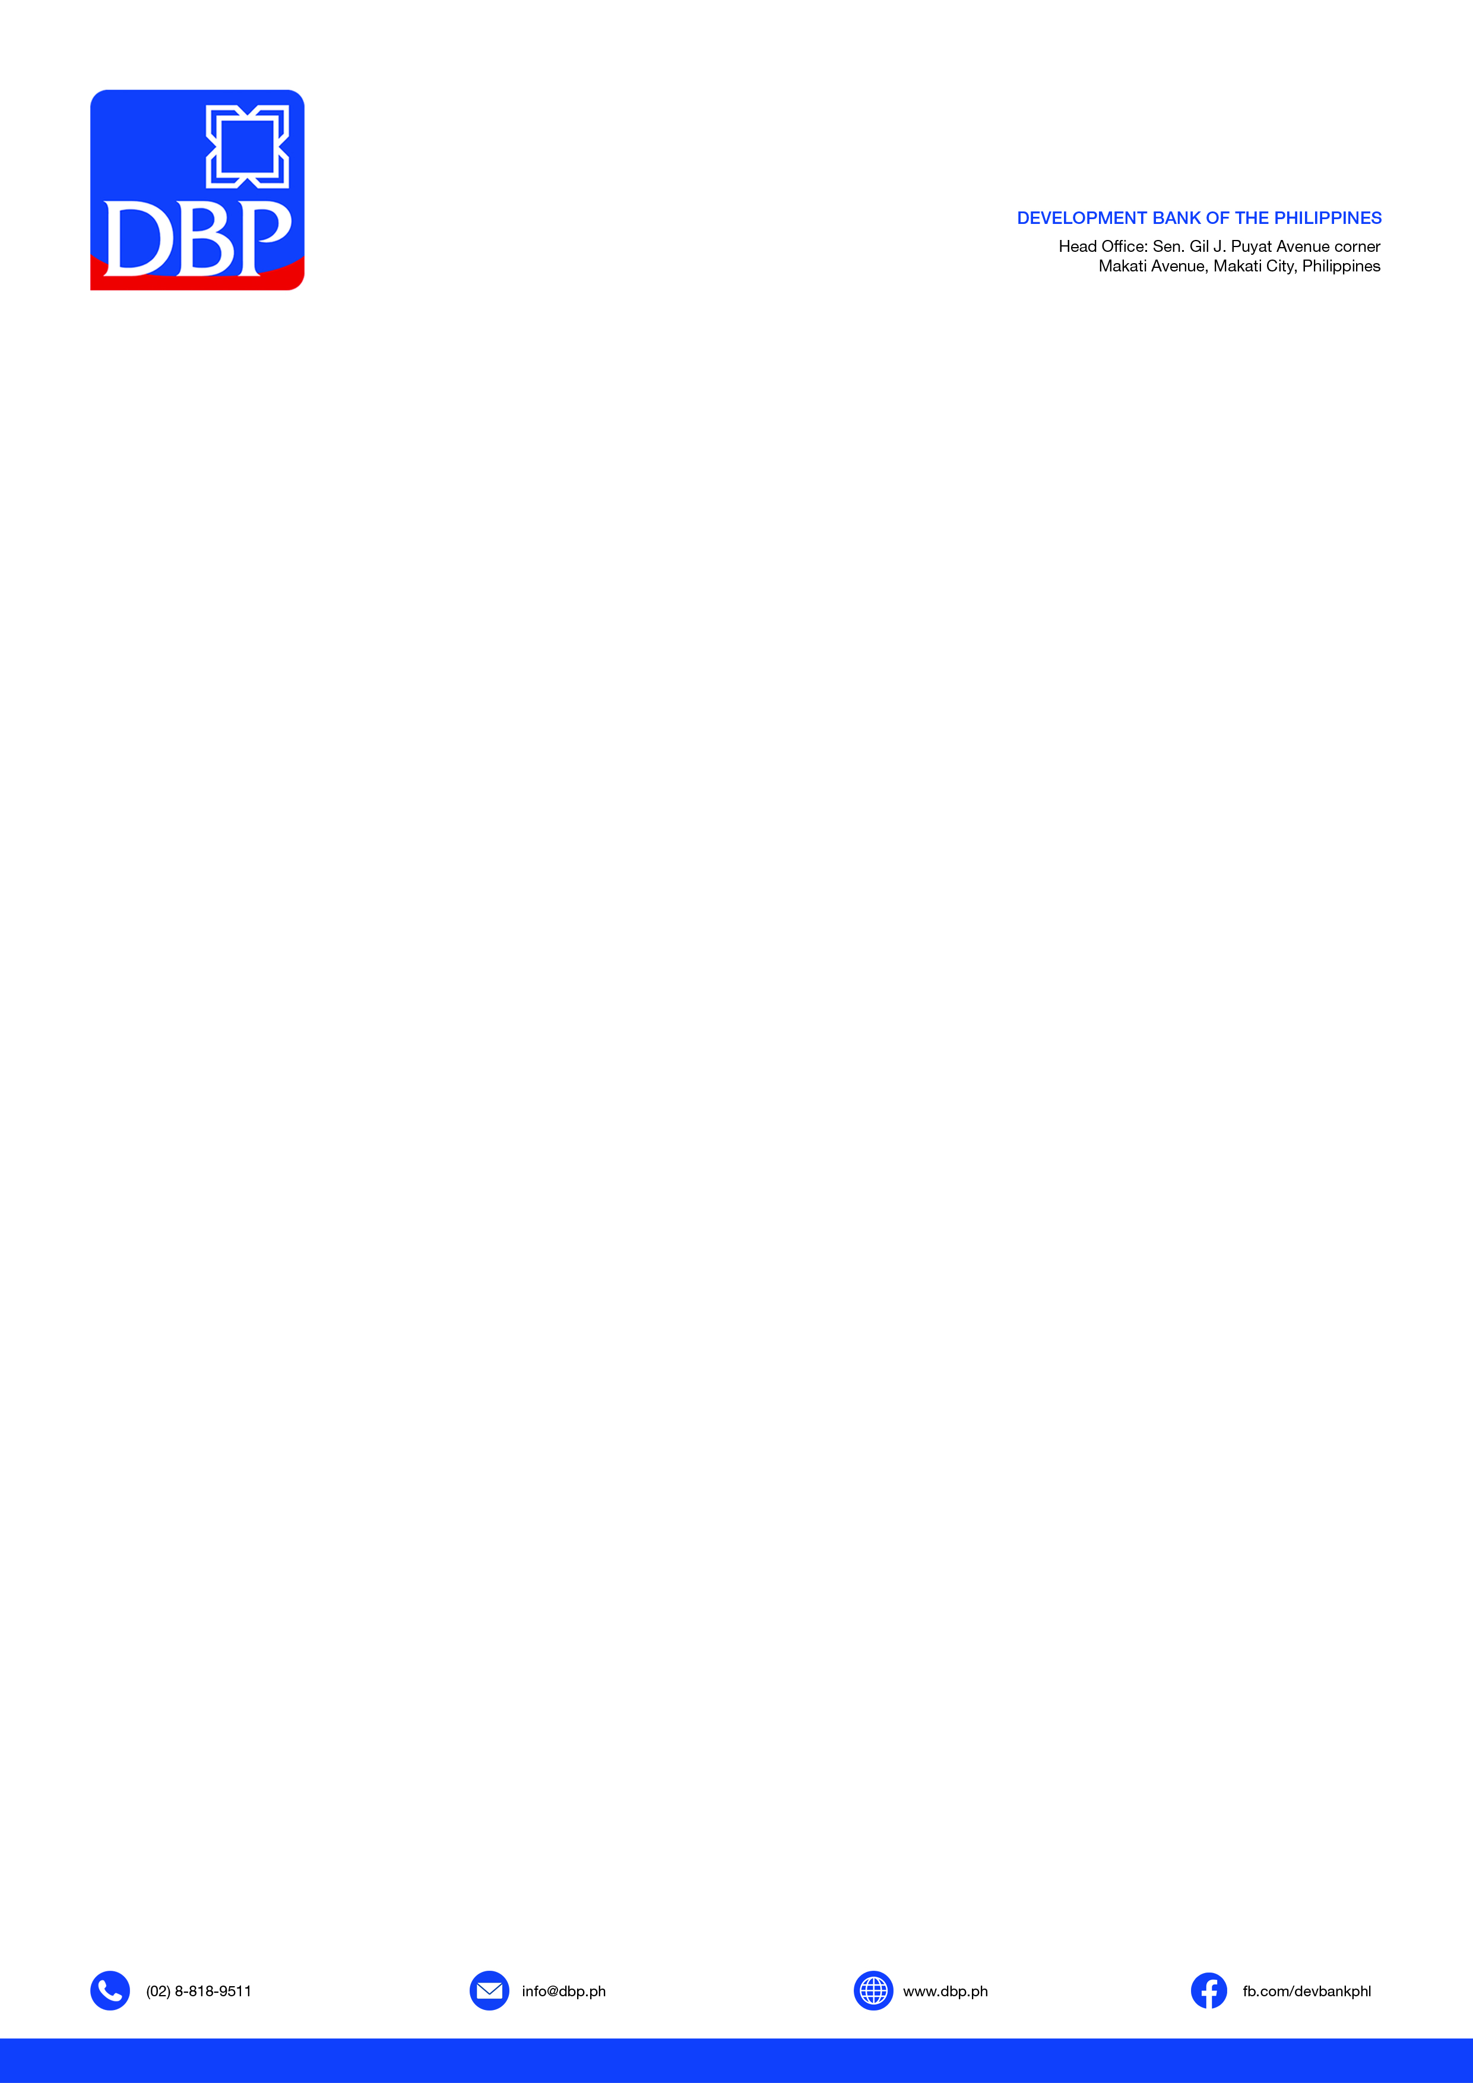

_________________________________

Signature over printed name of Owner /

Authorized Representative

_________________________________

Contact Number