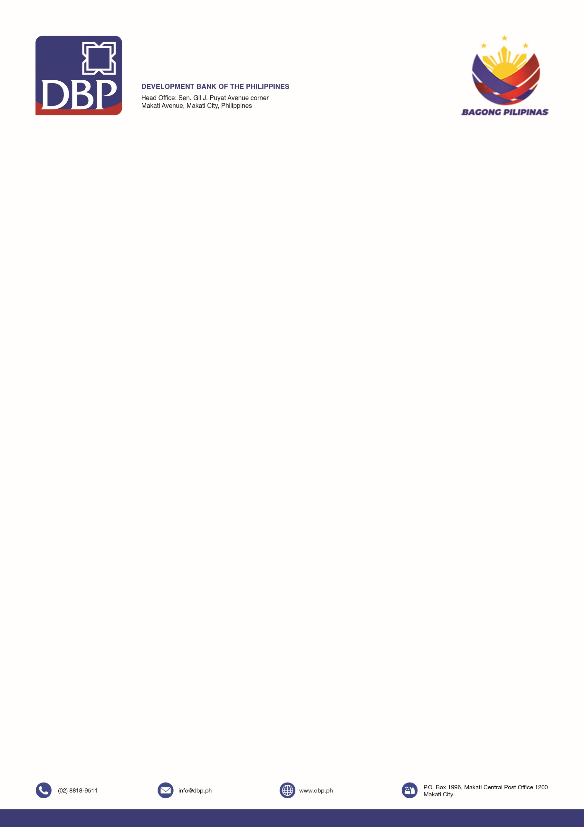

**TERMS OF REFERENCE**

**PROJECT : SUPPLY, DELIVERY, INSTALLATION, TESTING, COMMISSIONING OF ONE (1) 5TR FLOOR MOUNTED, TWO (2) 1.HP WALL MOUNTED, ONE (1) 3TR FLOOR MOUNTED AIR CONDITIONING UNITS**

**LOCATION : DBP MASBATE BUILDING, DANAO COR MABINI STREET, BRGY. BAPOR, MASBATE CITY, MASBATE 5400**

**DBP PLACER BRANCH, BALANGAWAN COR AVENIDO STREET, PLACER, MASBATE 5408**

1. **APPROVED BUDGET FOR THE CONTRACT**

|  |  |  |
| --- | --- | --- |
| **DESCRIPTION** | **QUANTITY** | **Total Cost Inclusive of All Applicable Taxes** |
| 5TR Floor Mounted | 1 Unit | $$₱200,000.00$$ |
| 3TR Floor Mounted | 1 Units | $$₱165,000.00$$ |
| 1.5HP Wall Mounted | 2 Units | $$₱120,000.00$$ |
| Total Contract Price |  | $$₱485,000.00$$ |

1. **TECHNICAL SPECIFICATIONS**

**5TR Floor Mounted**

|  |  |  |
| --- | --- | --- |
| Unit Type |  | Inverter |
| Power Supply | Ph/V/Hz | 1 Phase/220V-230V/60Hz |
| Refrigerant |  | R32/R410A |
| Cooling Capacity | kj/H | 54,800 min |
| btu/H | 51,900 min |
| kw | 14.0 min |
| System Power Input | WATTS | 5,600 +/- |
| Energy Efficiency Ratio (EER) | Kj/W-Hr | 10.8 – 18.2 |
| Piping Connections Liquid | mm | 9.5 |
| Piping Connections Gas | mm | 15.9 |
| Maximum Piping Length | m | 50 |
| Maximum Piping Elevation/Vertical Separation | m | 30 |

**3TR Floor Mounted**

|  |  |  |
| --- | --- | --- |
| Unit Type |  | Inverter |
| Power Supply | Ph/V/Hz | 1 Phase/220V-230V/60Hz |
| Refrigerant |  | R32/R410A |
| Cooling Capacity | kj/H | 36,000 min |
| System Power Input | WATTS | 685 – 3,550 |
| Energy Efficiency Ratio (EER) | Kj/W-Hr | 10.8 – 18.2 |
| Piping Connections Liquid | mm | 9.5 |
| Piping Connections Gas | mm | 15.9 |
| Maximum Piping Length | m | 50 |
| Maximum Piping Elevation/Vertical Separation | m | 30 |

**1.5HP Wall Mounted**

|  |  |  |
| --- | --- | --- |
| Unit Type |  | Inverter |
| Power Supply | Ph/V/Hz | 1 Phase/220V-230V/60Hz |
| Refrigerant |  | R32/R410A |
| Cooling Capacity | kj/H | 4,026 – 12,240 |
| System Power Input | WATTS | 820 +/- |
| Energy Efficiency Ratio (EER) | Kj/W-Hr | 14.93 |

1. **DELIVERY ADDRESS AND PERIOD**

|  |  |
| --- | --- |
| **Delivery Address** | **Delivery Period** |
| One (1) unit 5TR  DBP Masbate Branch, Danao corner Mabini Street, Masbate City,  Masbate 5400  Two (2) units 1.5HP and One (1) unit 3TR  DBP Placer Branch, Balangawan Cor Avenido Street, Placer, Masbate 5408  (1 Unit 3TR) | Purchase shall be awarded in Purchase Order (PO) and the delivery, installation and testing of the unit, shall be completed within sixty (60) calendar days upon receipt of **Notice to Deliver, Install, Test and Commission from DBP.**  **Certificate of Acceptance (COA)** shall be issued upon delivery, installation, and testing of the Air Conditioning Units. |

1. **LIQUIDATED DAMAGES**

When the Supplier fails to satisfactorily deliver goods under the contract within the specified delivery schedule, inclusive of duly granted time extensions, if any, the Supplier shall be liable for damages for the delay and shall pay DBP liquidated damages, not by way of penalty, an amount equal to one-tenth (1/10) of one percent (1%) of the cost of delayed goods scheduled for delivery for every day of delay until such goods are finally delivered and accepted by DBP.

The maximum deduction shall be ten percent (10%) of the amount of contract. Once the maximum is reached, the DBP shall rescind the Contract, without prejudice to other courses of action and remedies open to it.

1. **WARRANTY**
2. One (1) year warranty upon final acceptance of the project. If ever the Air Conditioning Units developed trouble and/or malfunction within the warranty period, the same shall be repaired/parts replaced free of charge and its warranty be extended until such time the supplier completed the repair.
3. Cost of transportation and technician’s per diem shall be for the account of the supplier.
4. **PAYMENT**

One-time, full payment shall be issued upon complete delivery, installation including electrical wirings, testing and commissioning of Air Conditioning Units.

**VII. GENERAL CONDITIONS**

1. The Supplier shall ensure that the items delivered are in accordance with the specifications required by the DBP. DBP has the right to reject delivery if the item/s delivered were found to be defective and not in

accordance with the required specifications/model.

1. All works shall be closely coordinated with the staff of the DBP Masbate Branch to ensure that the same will not affect the operation of the Bank.
2. That the Supplier, in consideration of the payment to be made by DBP of the sum of money hereinafter specified, binds itself to pay, furnish, install all complete any and all material, labor, tools, equipment, supplies, utilities, transportation, superintendence, installation *including electrical wirings*, testing and commissioning of the Aircondition unit.
3. DBP shall be free and made harmless from any and all kinds of claims, damages, liabilities or courses of action in the event the Supplier violates any Terms and conditions hereof, including any and all liabilities arising from the Supplier’s non-compliance with the requirements of the Workmen’s Compensation, Social Security and other Labor Laws.
4. DBP may terminate/cancel the Purchase Order (PO)/Notice to Proceed (NTP) when the Supplier fails to deliver, perform and comply with its obligation.
5. Documentary Requirements:

Interested Supplier/s must submit the following:

1. Proposal/Quotation
2. Proof of PHILGEPS Registration
3. 2025 Mayor’s/Business Permit
4. Omnibus Sworn Statement

Recommended by:

|  |  |  |
| --- | --- | --- |
| **____________________________**  **ELISEO B. DANAO JR.**  Branch Services Officer  DBP Masbate Branch | **_________________________**  **VINCENT JOSEPH A. MANLAPAZ**  Branch Services Officer  DBP Placer Branch |  |

**Approved by:**

**_________________________**

**VP NOMERLITO A. JUATCHON**

OIC, Branch Banking Group-Bicol